WHAT IS MARKETING? HOW MARKETING WORKS? WHAT IS DIGITAL MARKETING?
Tasks

1.Pick any two apps you use daily (like Instagram, Zomato, or Flipkart) and describe one marketing strategy each app uses to attract or retain users.

APP | MARKETING STRATEGY | DESCRIPTION
Instagram | Personalized content | Instagram recommends posts and reels based on users’ interests and activity, keeping them engaged and encouraging them to spend more time on the app.
Zomato | Discount and Offers | Zomato attracts and retains users by offering discount coupons, cashback, and free delivery deals, encouraging customers to order more often.

2.Create a simple poster (digital or on paper, then click a photo) for a new food delivery service, highlighting one digital marketing channel you would use to promote it.<br><br><em><strong>Hint:</strong> Think about using Instagram ads, WhatsApp broadcasts, or influencer partnerships.</em>

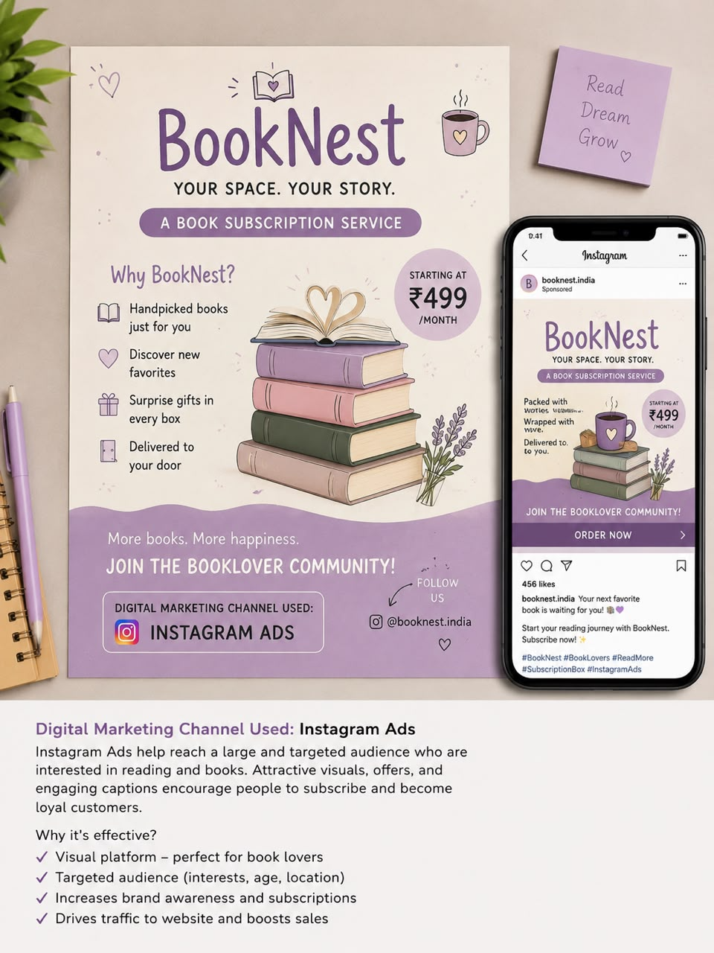
3.List 5 differences between traditional marketing (like newspaper ads, flyers) and digital marketing (like social media ads, email campaigns) in a table format.

TRADITIONAL MARKETING | DIGITAL MARKETING
Uses newspapers, TV, radio and flyers | Uses social media, websites, email and search engines.
Reaches a broad audience | Targets specific audiences based on age, location, and interests.
More Expensive | More cost-effective and budget-friendly.
Results are difficult to measure | Results can be tracked using analytics and reports.
Communication is mostly one-way | Communication is interative through comments, messages, and feedback.

4.Imagine you are launching a new playlist feature for a music app like Spotify. Write a short plan (5-6 lines) on how you would use digital marketing to get college students to try it.<br><br><em><strong>Hint:</strong> Mention specific digital channels or tactics, such as Instagram Reels, YouTube ads, or meme marketing.</em>
=> Answer :
Digital Marketing Plan for Spotify Playlist Feature :
1. Create short and engaging Instagram Reels to introduce the new playlist feature.
2. Run YouTube Ads targeting college students who enjoy music and entertainment.
3. Share funny and relatable memes on Instagram to increase engagement and make the feature popular.
4. Collaborate with student influencers to promote the playlist feature on social media.
5. Offer a 7-day Premium trial to encourage students to try the new feature.6. Track campaign performance using analytics and improve the marketing strategy based on user feedback.

